|  |  |
| --- | --- |
| RENT CAR MANAGEMENT SYSTEM  Project: Database management system | **Group Members:**  SHEIKH ABDUL MOIZ(004) MUHAMMAD SAMMAD(062) NOUMAN NAVEED(072) SHEIKH HASSAN(082)  Instructor: Faima Abbasi BUIC |

Contents

Introduction: 3

Requirement Analysis: 3

Conceptual Design: 4

Tables 5

Customer: 5

5

F.d: 5

Driver: 5

F.d: 5

Reservation: 6

Vehicle: 6

F.d: 6

Customer: 7

Driver: 7

Customer: 8

Vehicle: 9

Driver: 10

DATABASE CREATION IN SQL: 11

DRIVER table : 11

Creating table Customer: 12

Creating Table Vehicle: 12

Creating Table RESERVATIONS: 13

JOINS: 13

Significance of Design: 15

CONCLUSION: 15

## Introduction:

This report defines our project “**CAR RENTAL SERVICE IN RAWALPINDI & ISLAMABAD**”. The main goal to make this system is to store the Data of cars, customers, drivers and reservation schedule. The report will be containing brief information of project with the help of ER diagram (at the end of report).

## Requirement Analysis:

Registered user can avail the following functions:

* User can freely reserve a vehicle.
* User can freely negotiate with the dealer regarding fares.
* User will be provided with vehicle with good condition.
* If user demands a driver then he can check the details of drivers for security purpose.
* There will no need of gathering information from customer again and again because one time given information would be stored in the database.
* User can rate the driver and service out of 10 or report if any complaint.
* If user wants a certain vehicle that is not available at the moment then he would be notified with the available vehicles.
* User would be provide with notifications if any updates in the system through any email or sms.

## Conceptual Design:

***ER –DIAGRAM OF CAR RENTAL-SERVICE IN RAWALPINDI and ISLAMABAD***

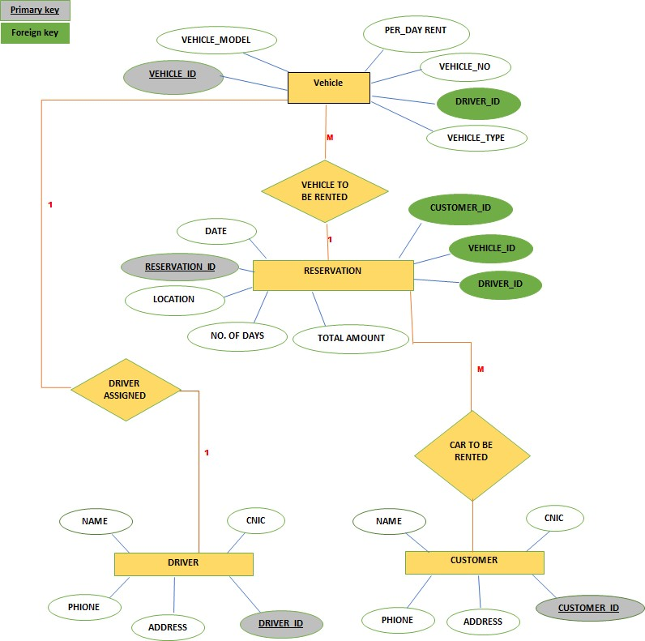

## Tables

### Customer:

### 

### F.d:

Customer_id →Name Cnic→Name,phone,address

### Driver:

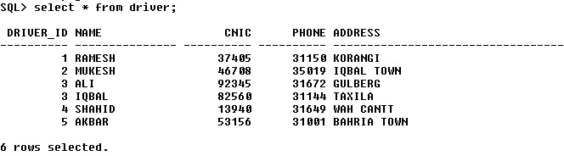

### F.d:

Driver_id →Name

Cnic →Name,phone,address

### Reservation:

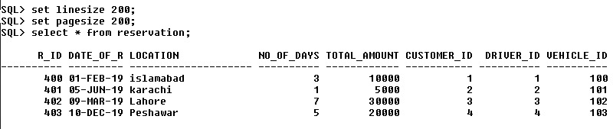

### Vehicle:

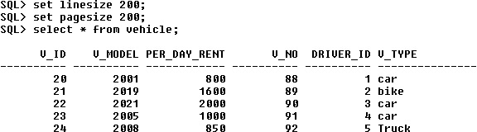

### F.d:

V_id →Model,V_no,V_type V_Model, V_type →per_Day_Rent V_id →Driver_Id

*1NF*

# Customer:

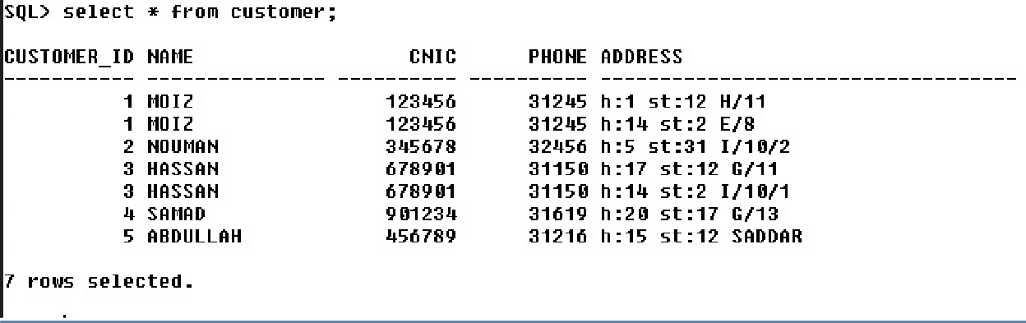

# Driver:



*2NF*

# Customer:

* ***Partial:***

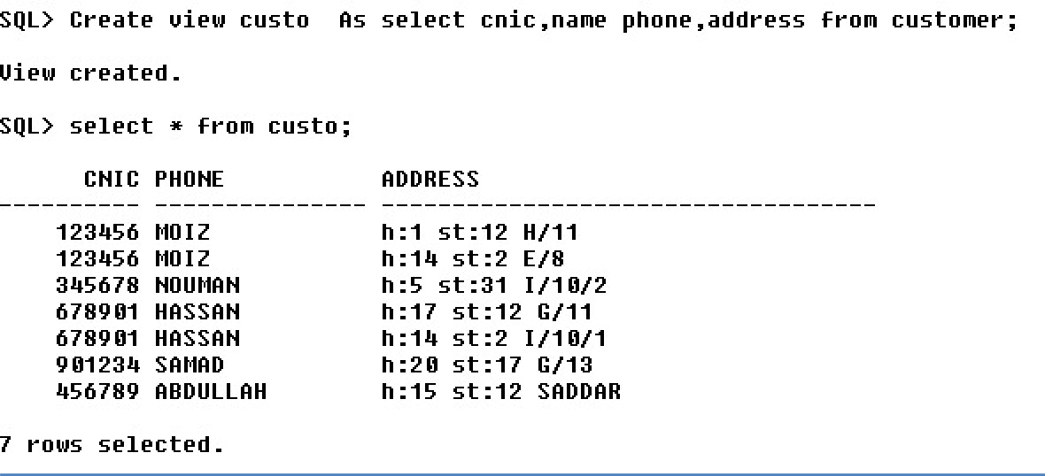

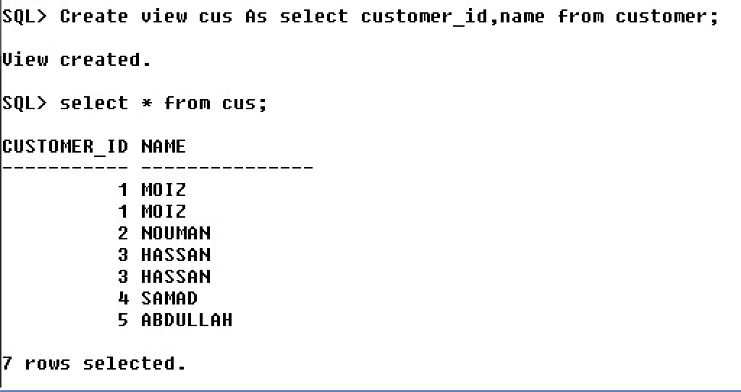

# Vehicle:

* ***Partial:***

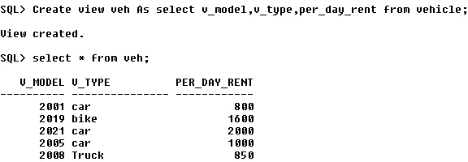

* ***Full:***

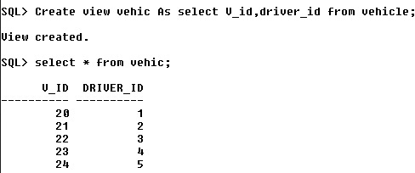

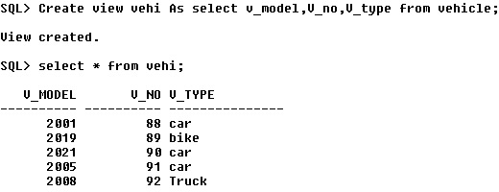

# Driver:

* ***Partial:***

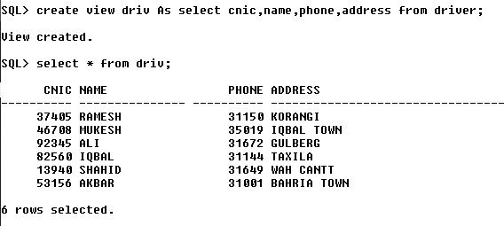

* 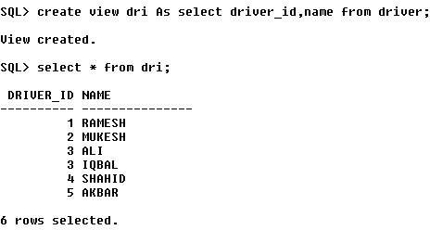***Full:***

*3NF*

All tables are already in 3nf.

## DATABASE CREATION IN SQL:

### DRIVER table :

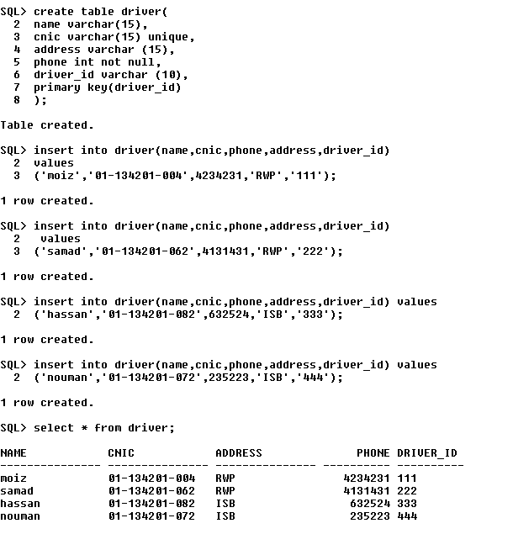

### Creating table Customer:

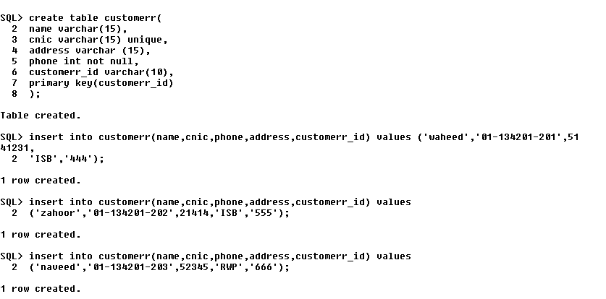

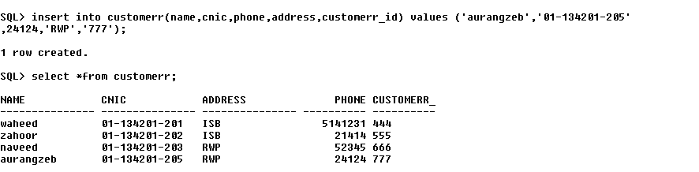

### Creating Table Vehicle:

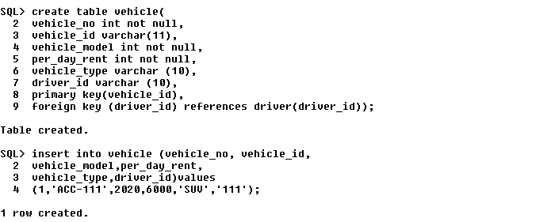

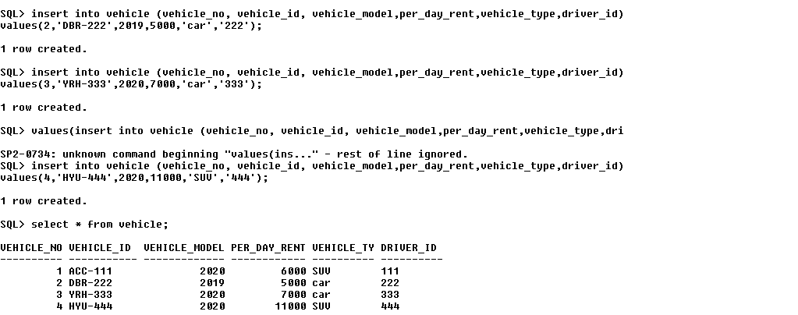

### Creating Table RESERVATIONS:

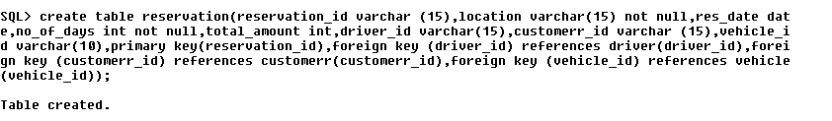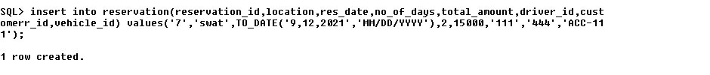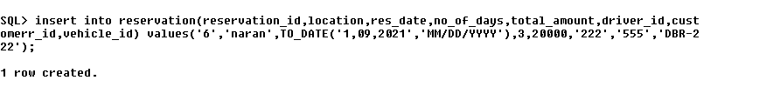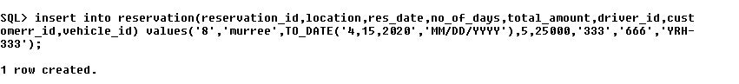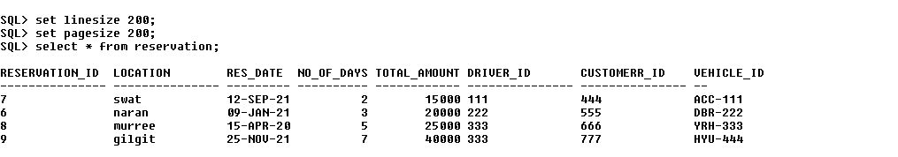

## JOINS:

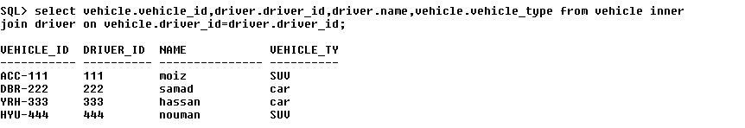

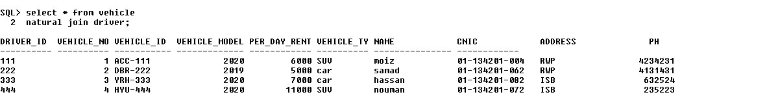

## Significance of Design:

The shown ER design is sketching of the design of database. It shows the

relationships of entity sets stored in a database. By defining the entities, their attributes, and showing

the relationships between them, an ER diagram illustrates the logical structure of databases. It assists the database designer in identifying both the data and the rules that are represented and used in a database. It makes easier to build a reliable database.

## CONCLUSION:

In conclusion, the system will be able to serve as a web base application when it is finally developed, where these small upcoming companies can make use of it to publish their services in a wide range and also help the company to manage their service more effectively. On the other hand, it will enable customers to freely make their desire choice more freely and interactively.

================================THE END===========================